<https://connectship.com/Members/Download/Current/Toolkit.aspx>

<https://connectship.com/Members/Download/Current/Warehouse.aspx>

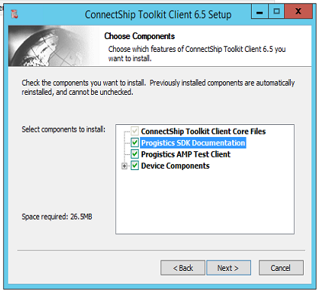

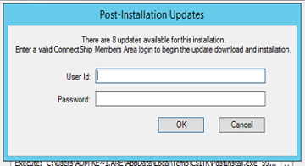

Kevin.Arellano@PBD

1Arellano